Postprocessor user’s guide for Mikron WF21D

This is a 3-Axis Milling Machine.
- Machine Name ……………………………Mikron
- Model Number .…………………………...WF 21 D
- Type of machine…………………………...CNC Milling machine
- Controller ……... …………………………Heidenhain TNC 407
- Number of axes ……………………………3 axes

In order to use this postprocessor correctly, you should follow the instruction below.

Assign program number
To assign an attribute to the program, right click on the program. Under properties, select attribute. Use the string "program_number" as the title of the attribute. Enter the string you need for the program name, 123 for example, as the value of the attribute. Use type string for the attribute. Each program group can have a unique program number.
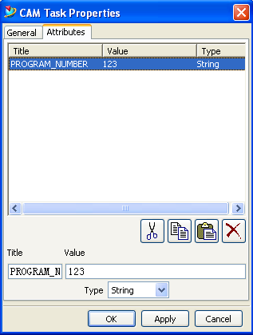

UDE installation
- Open the UDE file in the UDE directory: UGII_CAM_USER_DEF_EVENT_DIR (typically mach\resource\user_def_event)
- Append the mikron.txt file to the UDE file.

In the program order view, add the Cycle Parameter UDE to the operation
  - Highlight the cycle operations which need to specify some parameters, using MB3, select OBJECT→ Start Events. The User Defined Events dialog is displayed.
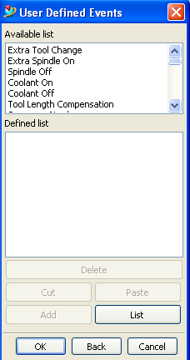
  - Select ‘Cycle parameter’ from the Available list items, then choose the Add button.
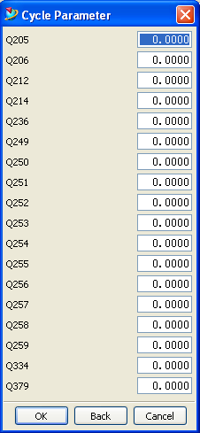
This post supports the following 6 different type cycle. You should add the UDE to the cycles which need to specify the cycle parameters.

DRILLING (Cycle 200)
REAMING (Cycle 201)
BORING (Cycle 202)
BACK BORING (cycle 204)
UNIVERSAL PECKING (Cycle 205)
RIGID TAPPING NEW (Cycle 207)

Then you can use this postprocessor to output the G code directly.

